**12 - ServiceNow Incident Management Tutorial and Task Administration**

A task is a piece of work that needs to be completed. In ServiceNow, each task is represented by a record in the Task [task] database table. The most common types of tasks in ServiceNow are Incident, Problem, and Change Request.

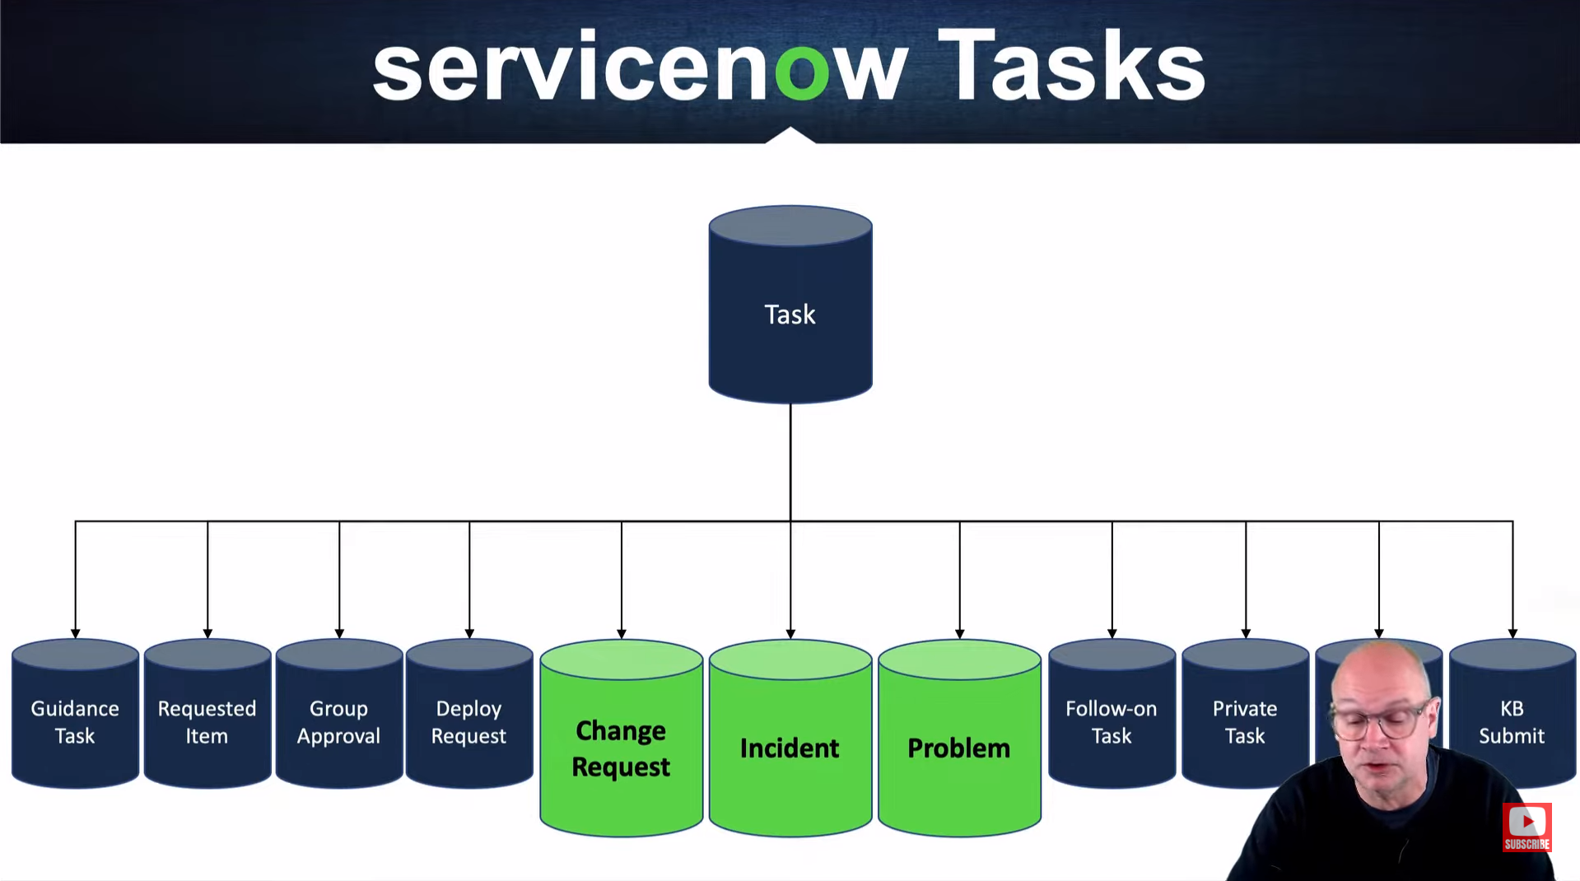

**Task Management -** Defining and managing tasks in ServiceNow allows users to standardize common work processes. Assignment Rules automatically assign tasks to the most appropriate users or groups. Approval rules create lists of approvers as needed.

**Service Level Agreements** (SLAs) track how long tasks have been open to ensure timely completion. Inactivity monitors notify users when tasks have been untouched for a specified time, preventing them from being overlooked. Workflows automate processes for tasks that meet certain conditions.

**Task Assignment -** Tasks can be assigned to individual users or groups.

**Assignment rules -** To manage Assignment Rules, navigate to All > System Policy > Rules > Assignment in the Application Navigator.

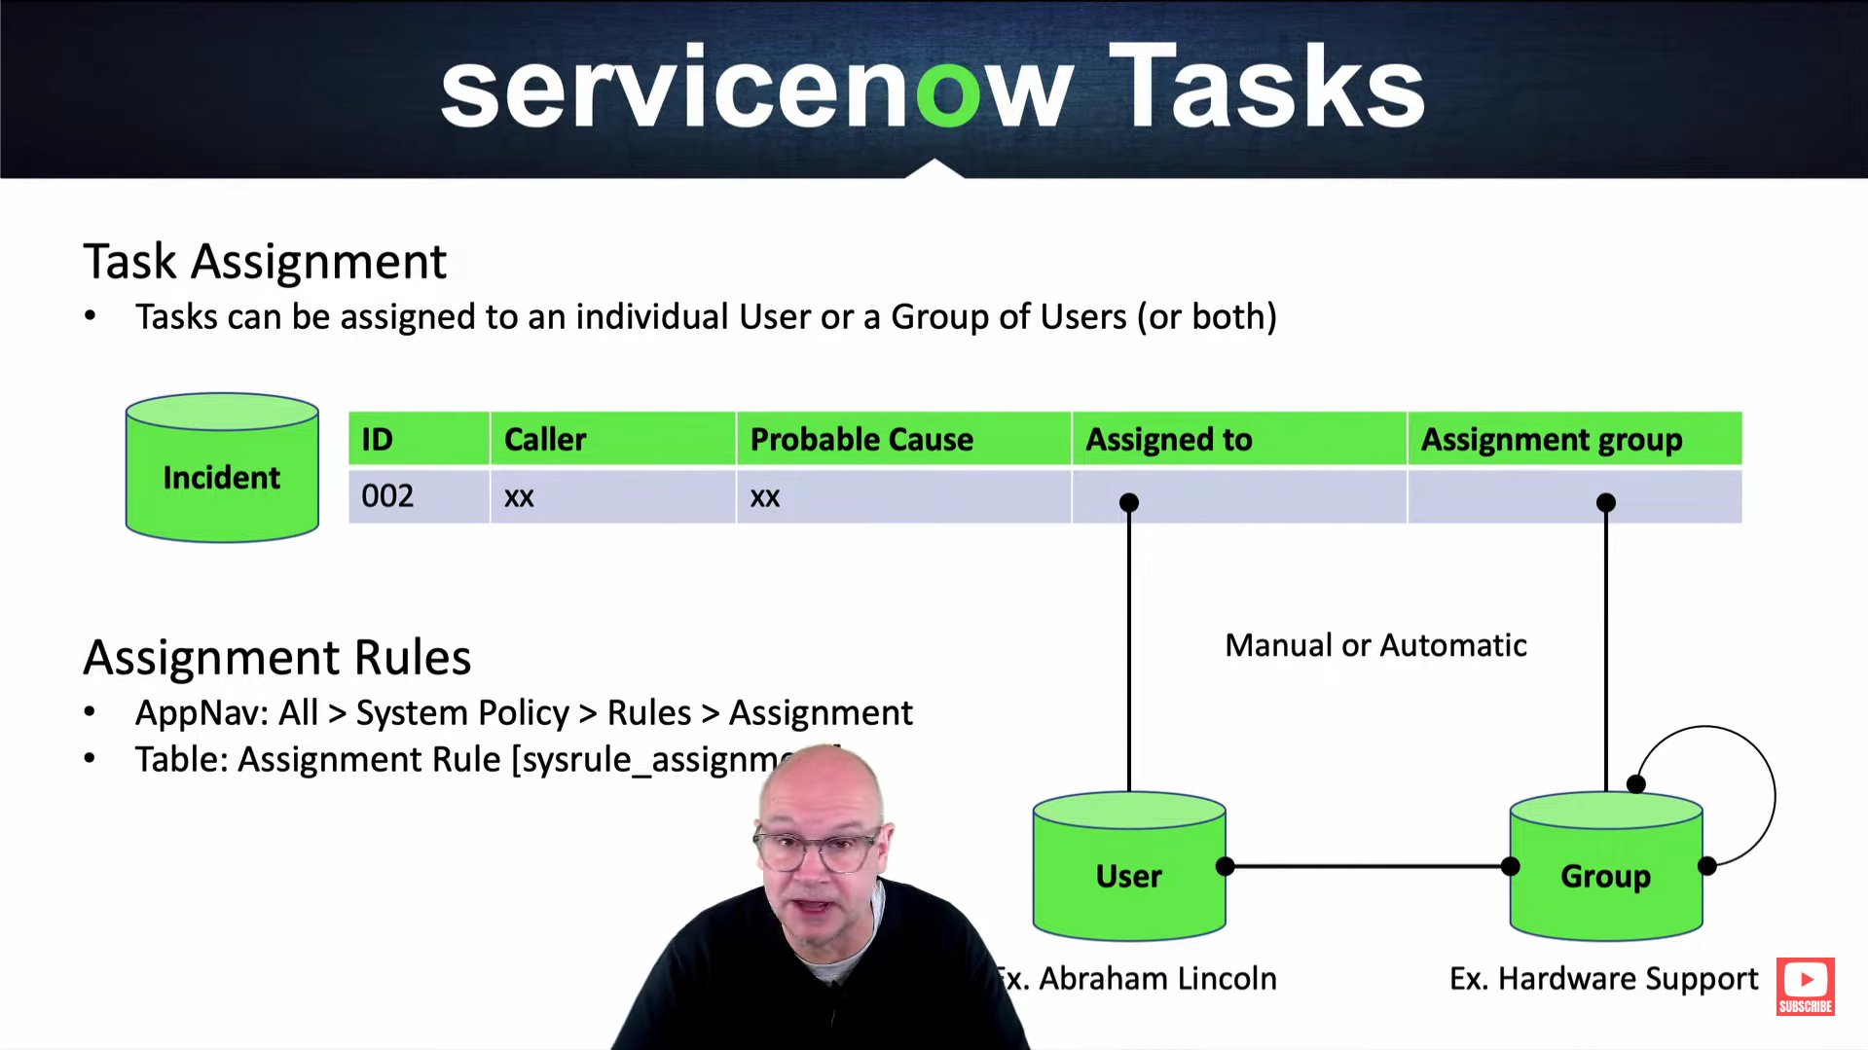

**Task Collaboration** - User Presence allows multiple stakeholders to view and update a record at the same time.

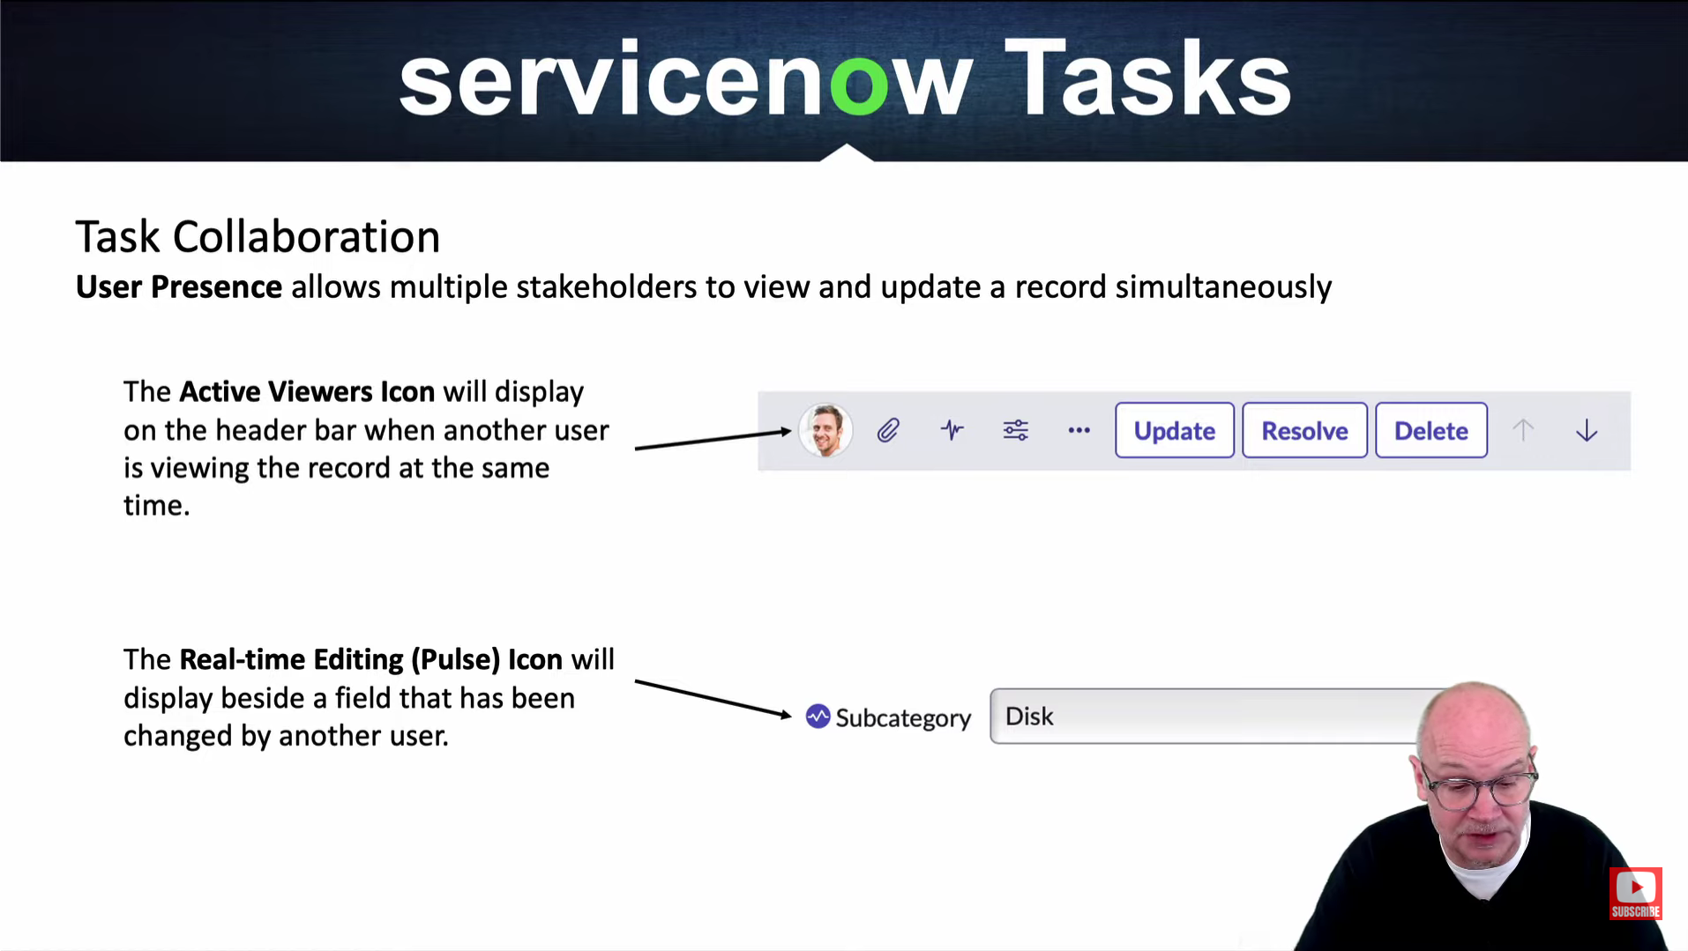

**Visual Task Boards -** Visual Task Boards (VTB) change the way you navigate lists and forms by providing an interactive graphical experience. There are three types of Visual Task Boards: -   
 Guided - Created from a list with an attribute that has predefined values as lanes. Task values are updated when cards are moved between lanes.

Flexible - Created from a list with an attribute that does not have predefined values as lanes. Task values are not updated when cards are moved between lanes.

Freeform - Not created from a list, used for personalized work management with private tasks.

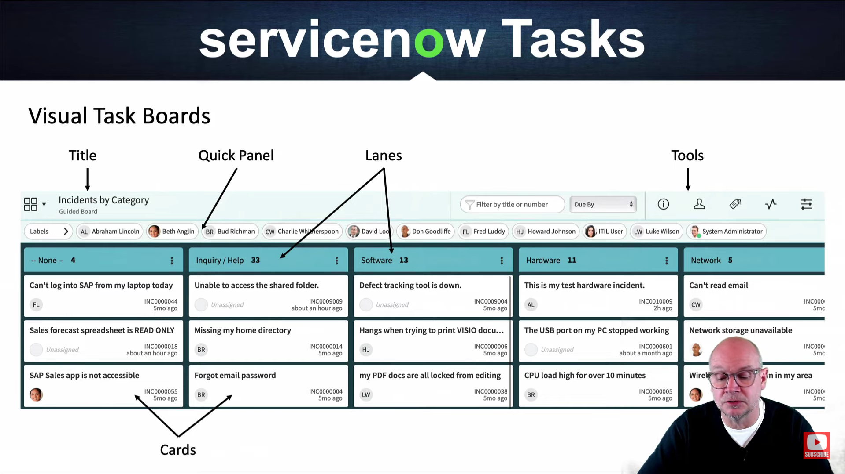

ANANYA CHOUDHARY